**Smart and compact electrical appliance management system through IoT (Internet of things) implementation, along with power regulation and monitoring features using high voltage semiconductor devices.**

Noor Al Din Ahmed, Rahatul Aine

**Faculty Advisor: Dr. Tanzilur Rahman**

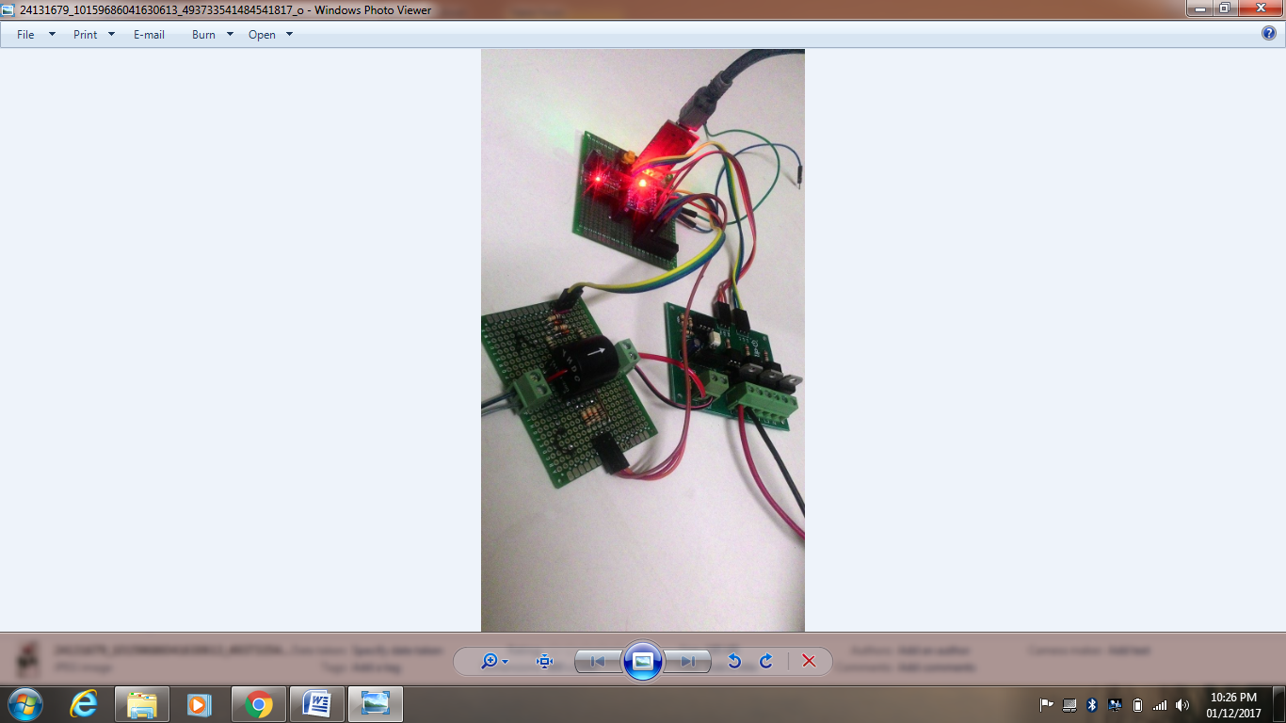

Figure: Prototype of the system.

In today’s world everything is becoming modernized and almost everything is being controlled electronically and wirelessly. Keeping with the trend the world at present is seeing increased amounts of automation in homes because it provides ease, security and efficiency. Iot (Internet of things) based Home Automation System usually signifies the control of home appliances using computer technology. Although it is not as expensive as it used to be it is still quite costly and for that it has not been implemented largely in a developing country like ours. Hence we took on task of making a project which would involve automation of homes at a reasonable price with parts that are available within our country.

In this project we have developed a Home Automation system based on Internet of Things. This whole system using Internet of Things (IoT) will allow users to control all the functions and features of home appliances remotely from anywhere around the world through mobile devices and computers using the internet connection. Here, we have introduced a system which can control the switching of the power outlets in terms of controlling various electrical appliances, such as lights and fans or any inductive load that can be voltage regulated and/or switching various devices on and off. We have built a semiconductor based system throughout the circuit to reduce the form factor and the price of the overall product. We made a Zero Crossing Detector (ZCD), a Thyristor based switching circuit to control the power output to the loads. To make these two units talk to each other, an algorithm has been implemented to the system’s main processing core which is the Arduino Pro Mini and this code helps to process the signals towards the input of the load. Since the whole unit needs to be controlled through the web, a web server is also built along with a database and API functionality. Currently, the completion of our product is done and it is affordable and ready for customers to use now. Our product can not only be used in residential buildings but also it can be used in office buildings, hospitals etc to manage certain room conditions.